SIMATS ENGINEERING
ASSESSMENT TOOL 1
Application-Based Questions

NAME: B. Baby Suharshitha
REG NO: 192372371
COURSE NAME: Internet Programming
COURSE CODE: CSA4308

Question 1:
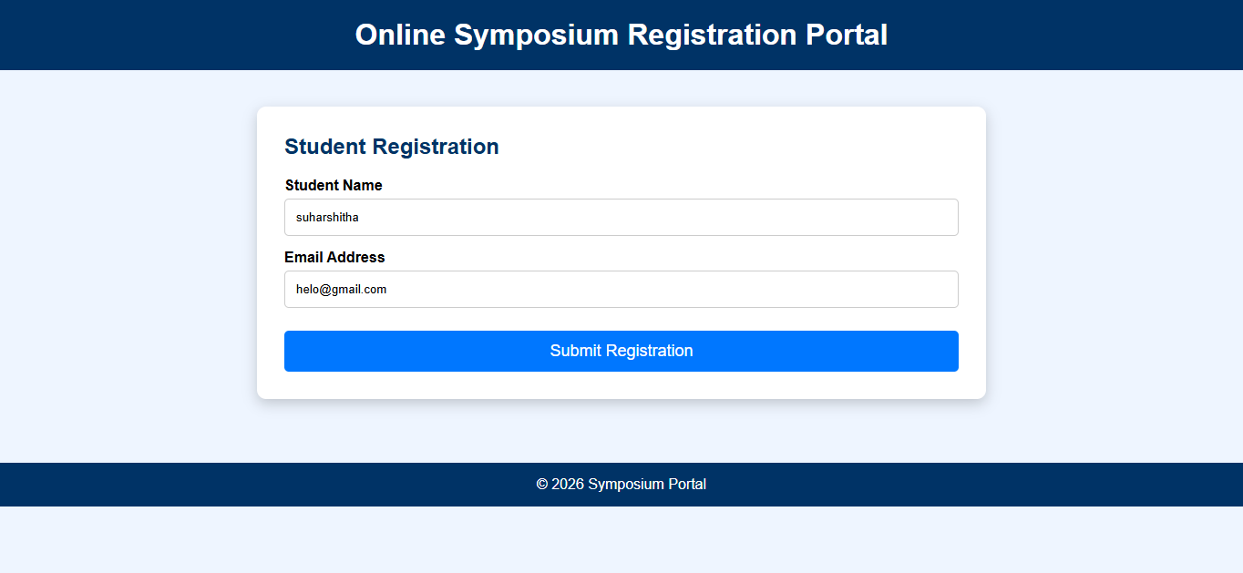
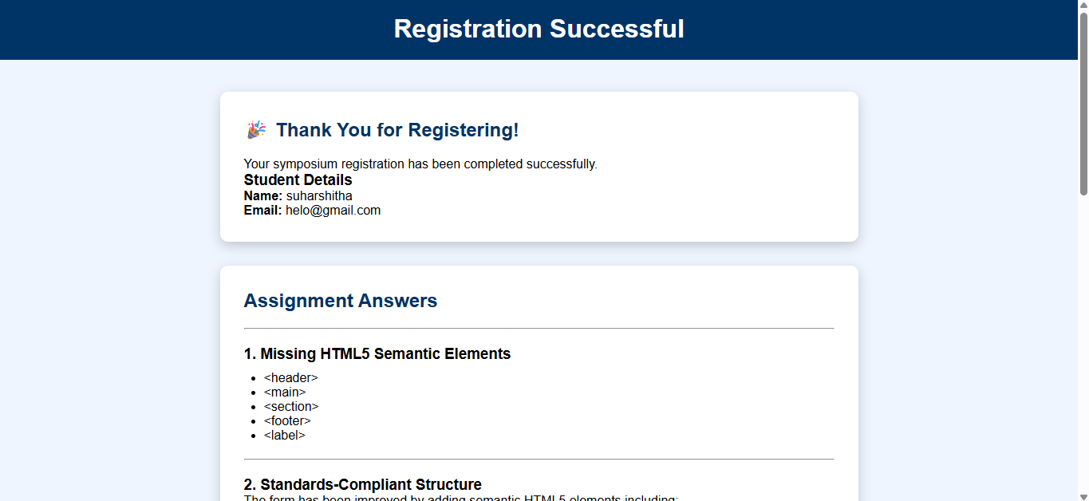

1. Missing HTML5 Semantic Elements
- <header>
- <main>
- <section>
- <footer>
- <label>

2. Standards-Compliant Structure
The form has been improved by adding semantic HTML5 elements including:
- Header
- Main
- Section
- Footer
- Proper labels
- Required attributes
- Placeholder text

3. HTTP Request Generated
When the Submit button is clicked, the browser creates an HTTP POST request.

POST /register HTTP/1.1

Host: symposium.com

Content-Type: application/x-www-form-urlencoded

name=StudentName&email=student@email.com

The request contains the form data and sends it to the server.

4. HTTP Response Cycle
- Browser sends HTTP POST request.
- Server receives request.
- Server validates the data.
- Server stores registration in database.
- Server sends HTTP Response (200 OK).
- Browser loads the success page.

5. Improvements for Usability and Accessibility
- Use semantic HTML5 elements.
- Add labels for every input.
- Use placeholder text.
- Use required validation.
- Responsive design.
- Keyboard accessible form.
- Proper heading hierarchy.
- Readable color contrast.
- Display success confirmation.
- Mobile-friendly layout.

Question 2:
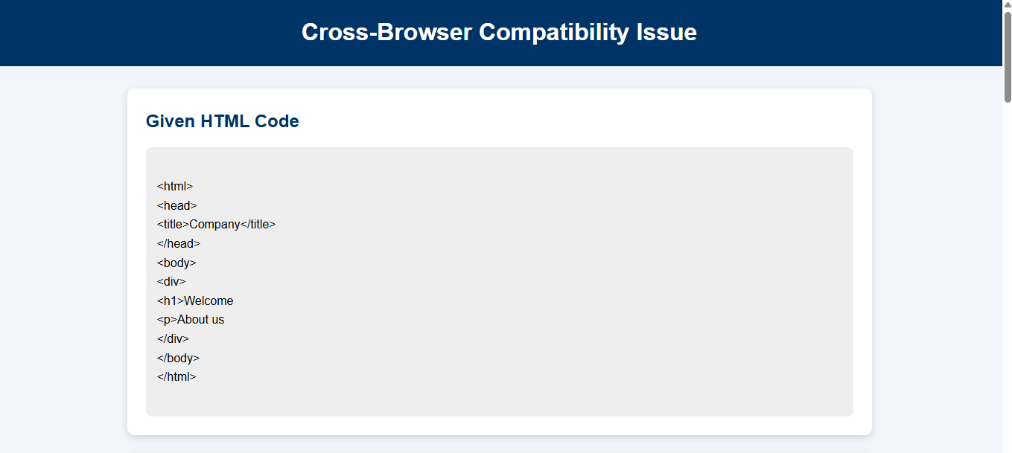

1. Improper Nesting and Missing Closing Tags
- The <h1> tag is not closed.
- The <p> tag is not closed.
- The HTML document does not include a DOCTYPE declaration.
- Semantic HTML5 elements are missing.

2. Browser Interpretation
Different browsers automatically attempt to correct invalid HTML.
- Chrome automatically inserts missing closing tags.
- Firefox repairs the HTML but may render spacing differently.
- Safari also autocorrects the structure.
- Older browsers may display inconsistent layouts because of improper HTML parsing.
Because browsers repair invalid HTML differently, the page layout may not appear the same across all browsers.

3. Missing Semantic Elements
- <header>
- <main>
- <section>
- <footer>

4. Corrected W3C-Compliant HTML Structure

<!DOCTYPE html>

<html lang="en">

<head>

<meta charset="UTF-8">

<meta name="viewport"
content="width=device-width, initial-scale=1.0">

<title>Company</title>

</head>

<body>

<header>

<h1>Welcome</h1>

</header>

<main>

<section>

<p>About us</p>

</section>

</main>

<footer>

<p>© 2026 Company</p>

</footer>

</body>

</html>

5. Techniques for Cross-Browser Compatibility
- Use valid W3C-compliant HTML.
- Always close HTML tags properly.
- Use semantic HTML5 elements.
- Add the HTML5 DOCTYPE declaration.
- Use CSS Reset or Normalize.css.
- Test the website in Chrome, Firefox, Edge, and Safari.
- Use responsive design with media queries.
- Validate code using the W3C HTML Validator.
- Avoid deprecated HTML tags.
- Use vendor prefixes only when necessary.

Question 3:
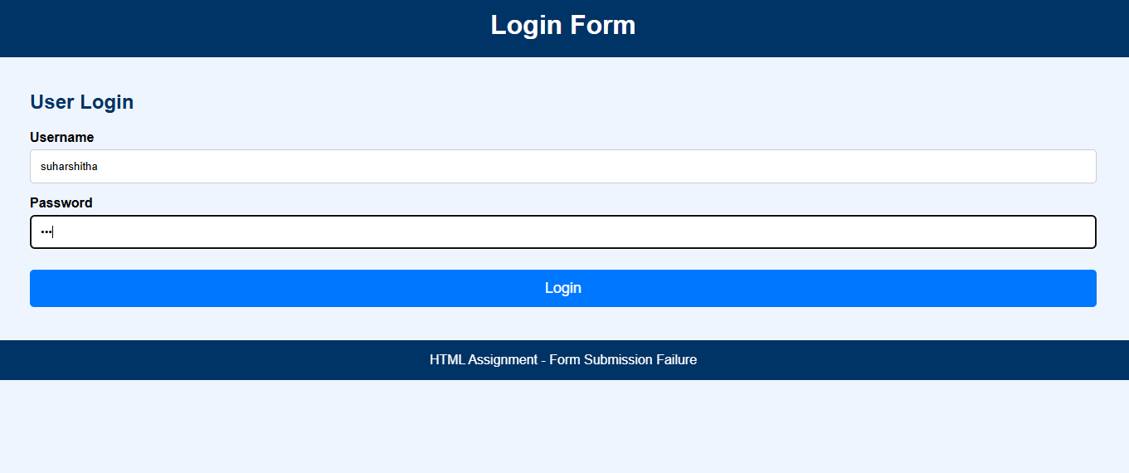
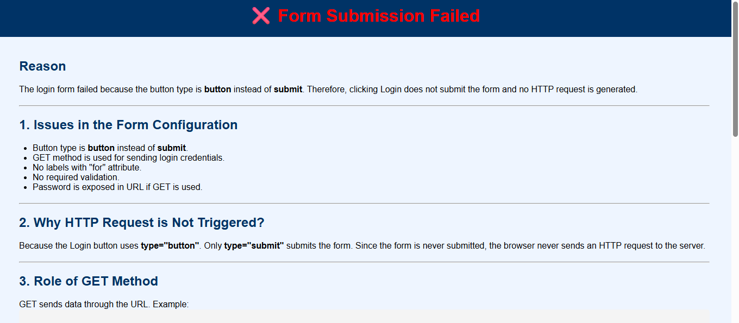

1. Issues in the Form Configuration
- Button type is button instead of submit.
- GET method is used for sending login credentials.
- No labels with "for" attribute.
- No required validation.
- Password is exposed in URL if GET is used.

2. Why HTTP Request is Not Triggered?
Because the Login button uses type="button". Only type="submit" submits the form. Since the form is never submitted, the browser never sends an HTTP request to the server.

3. Role of GET Method
GET sends data through the URL. Example:

https://example.com/submit?username=John&password=123

- Visible in URL.
- Stored in browser history.
- Not secure for passwords.
- Mainly used for searching and retrieving data.

4. Corrected Implementation

<form action="/submit" method="POST">

<label>Username</label>
<input type="text"
name="username"
required>

<label>Password</label>
<input type="password"
name="password"
required>

<button type="submit">
Login
</button>

</form>

5. Improvements for Secure Data Transmission
- Use POST instead of GET.
- Use HTTPS.
- Validate inputs.
- Hash passwords.
- Use CSRF protection.
- Use secure session management.
- Implement server-side validation.

